**SPRINT – 4**

|  |  |
| --- | --- |
| Date | 19 September 2022 |
| Team ID | PNT2022TMID54398 |
| Project Name | Project - Smart Fashion Recommender Application |
| Member Name | Prabhavathy.S  Karthikeyan.T  Divyesh.G  Murugeshwaran.V |

UPLOAD IMAGE TO IBM CONTAINER REGISTRY:

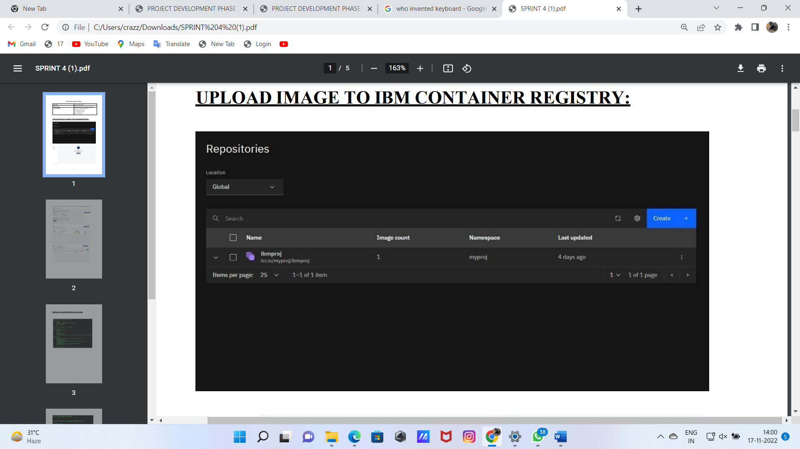

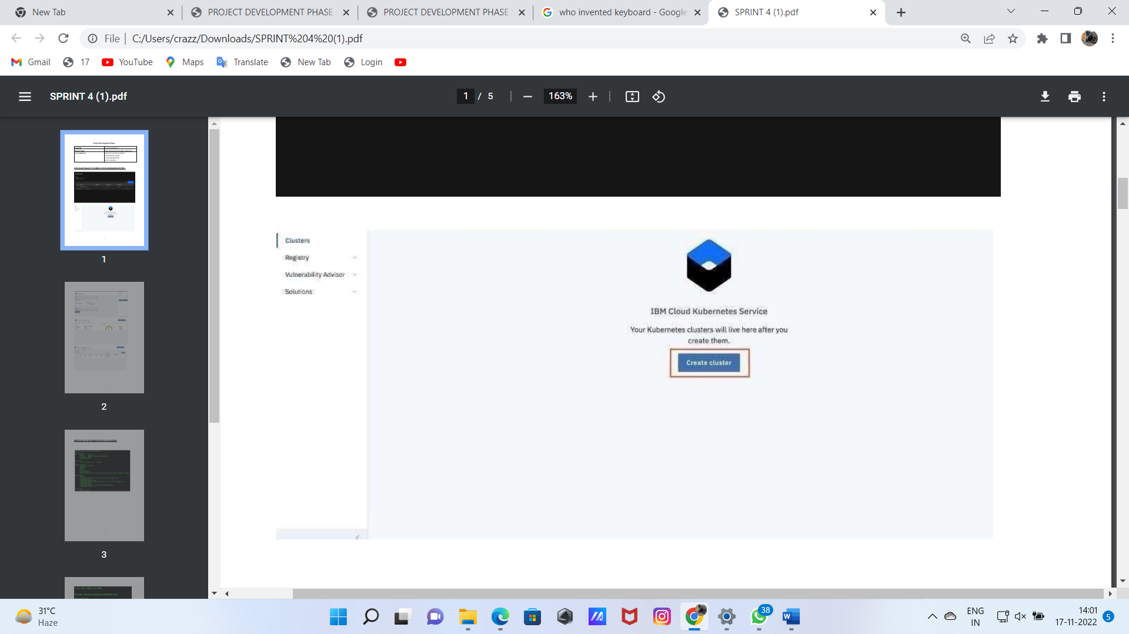

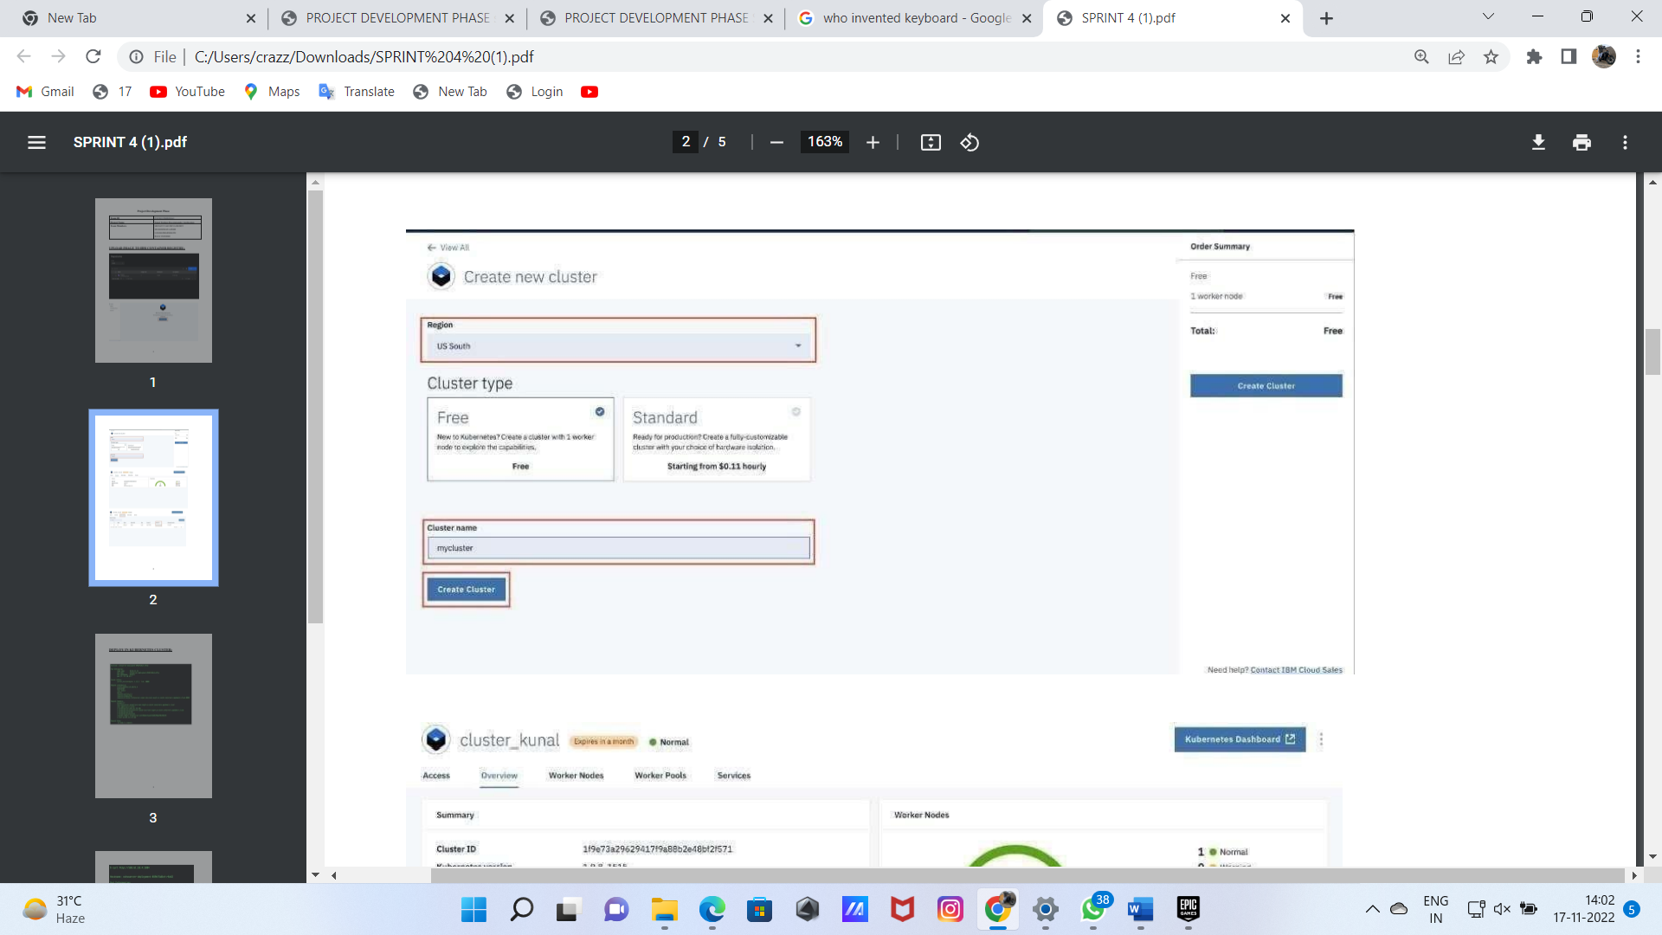

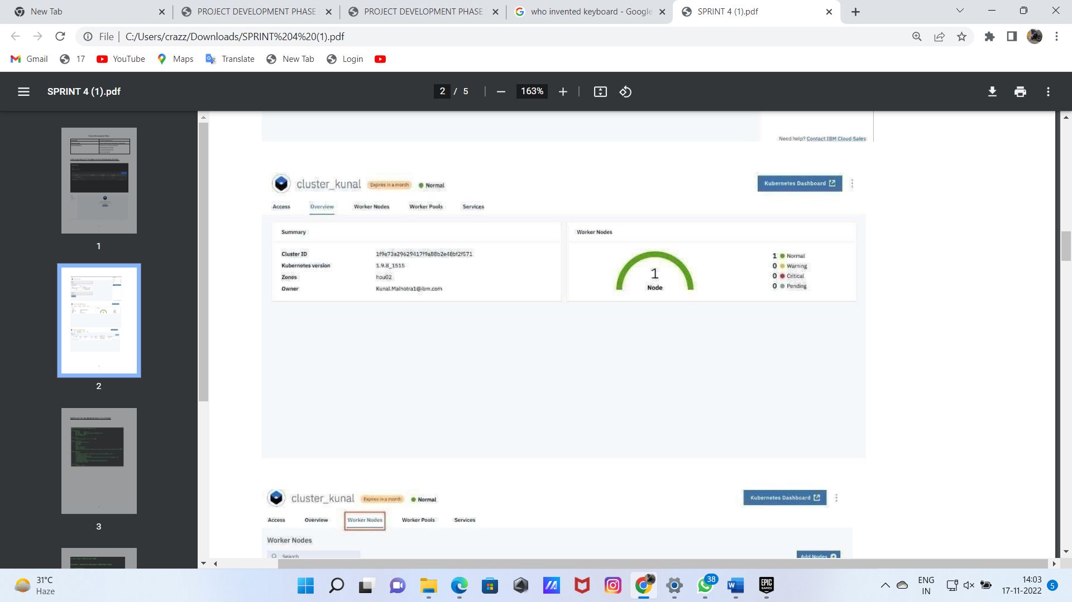

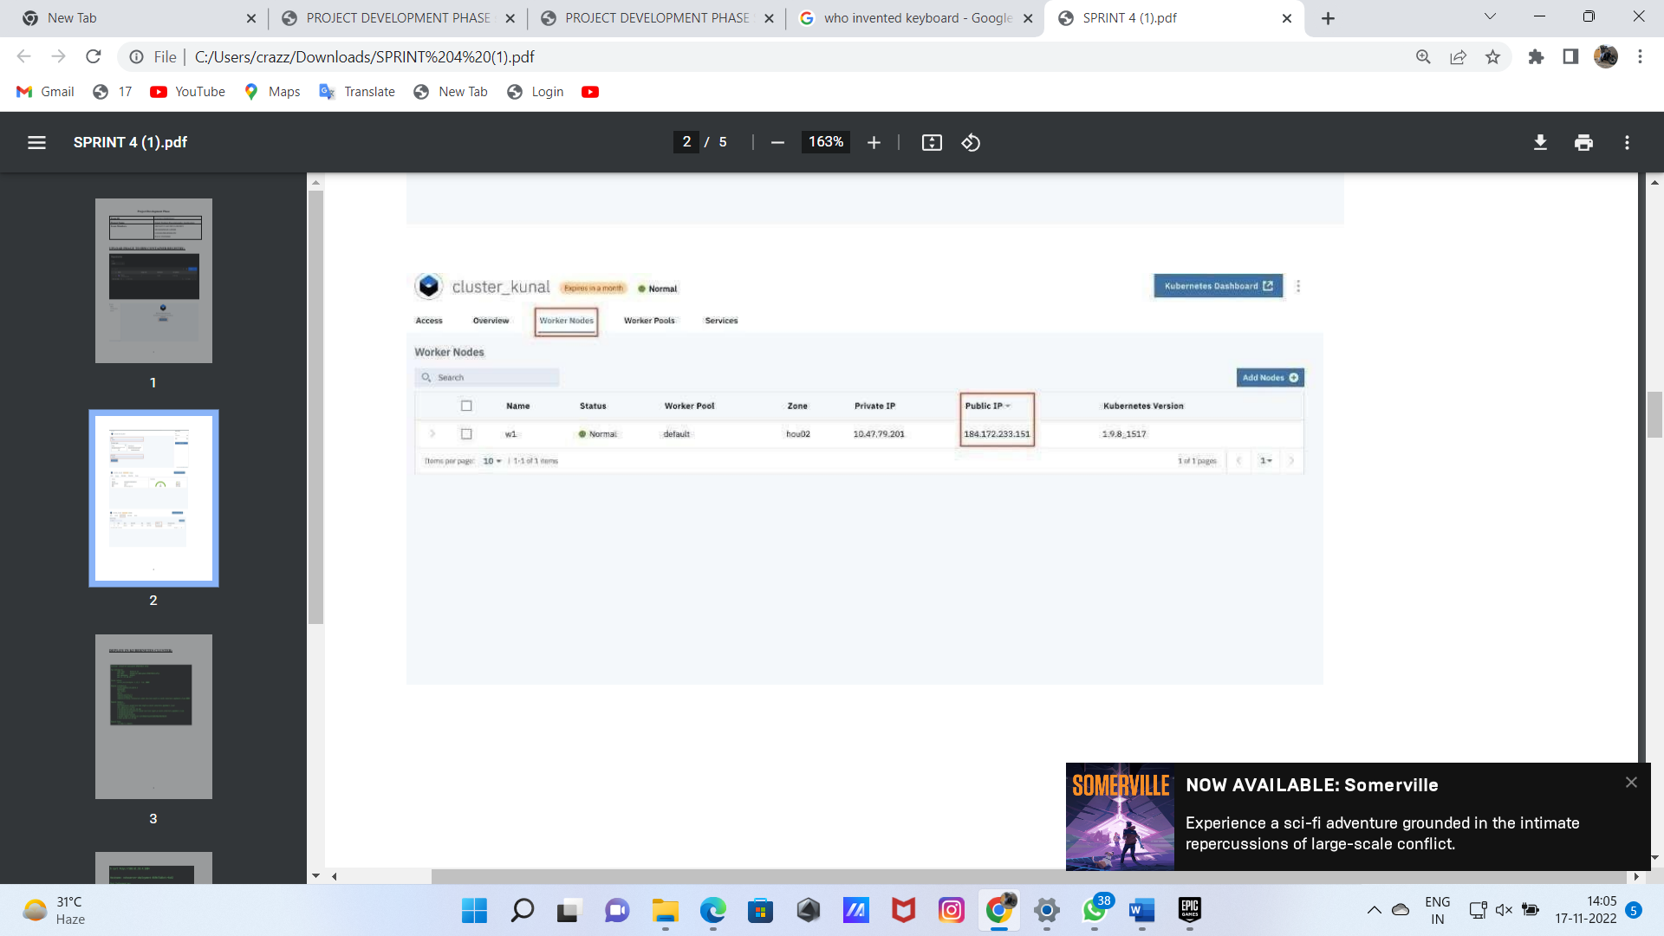

DEPLOY IN KUBERNETES CLUSTER:

